TDD using JUnit5 and Mockito
Exercise 1:
Create new java project and add Junit dependency
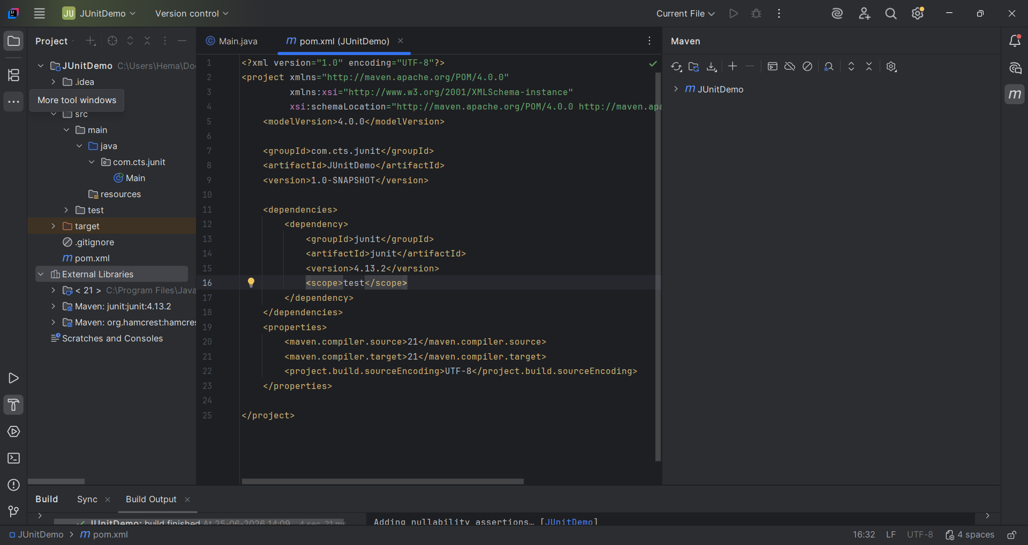

Exercise 2:
Writing basic Junit Tests
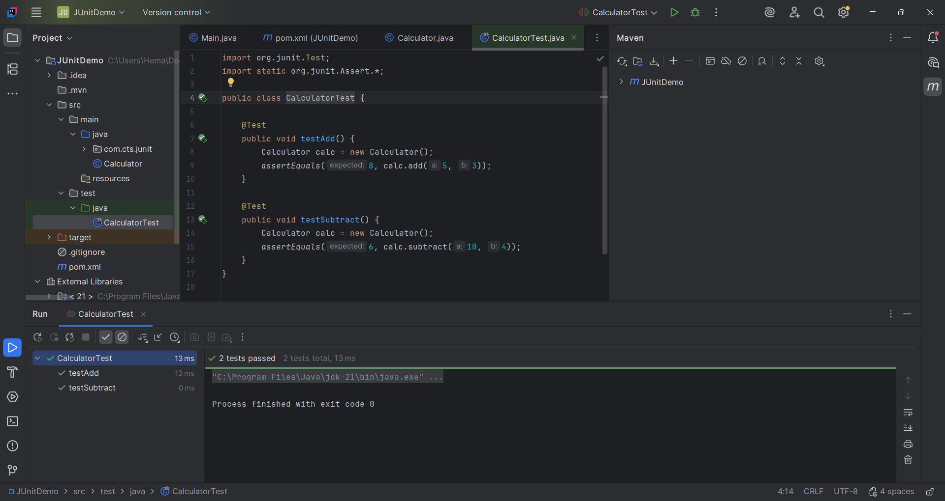

Exercise 3:
Assertions in Junit
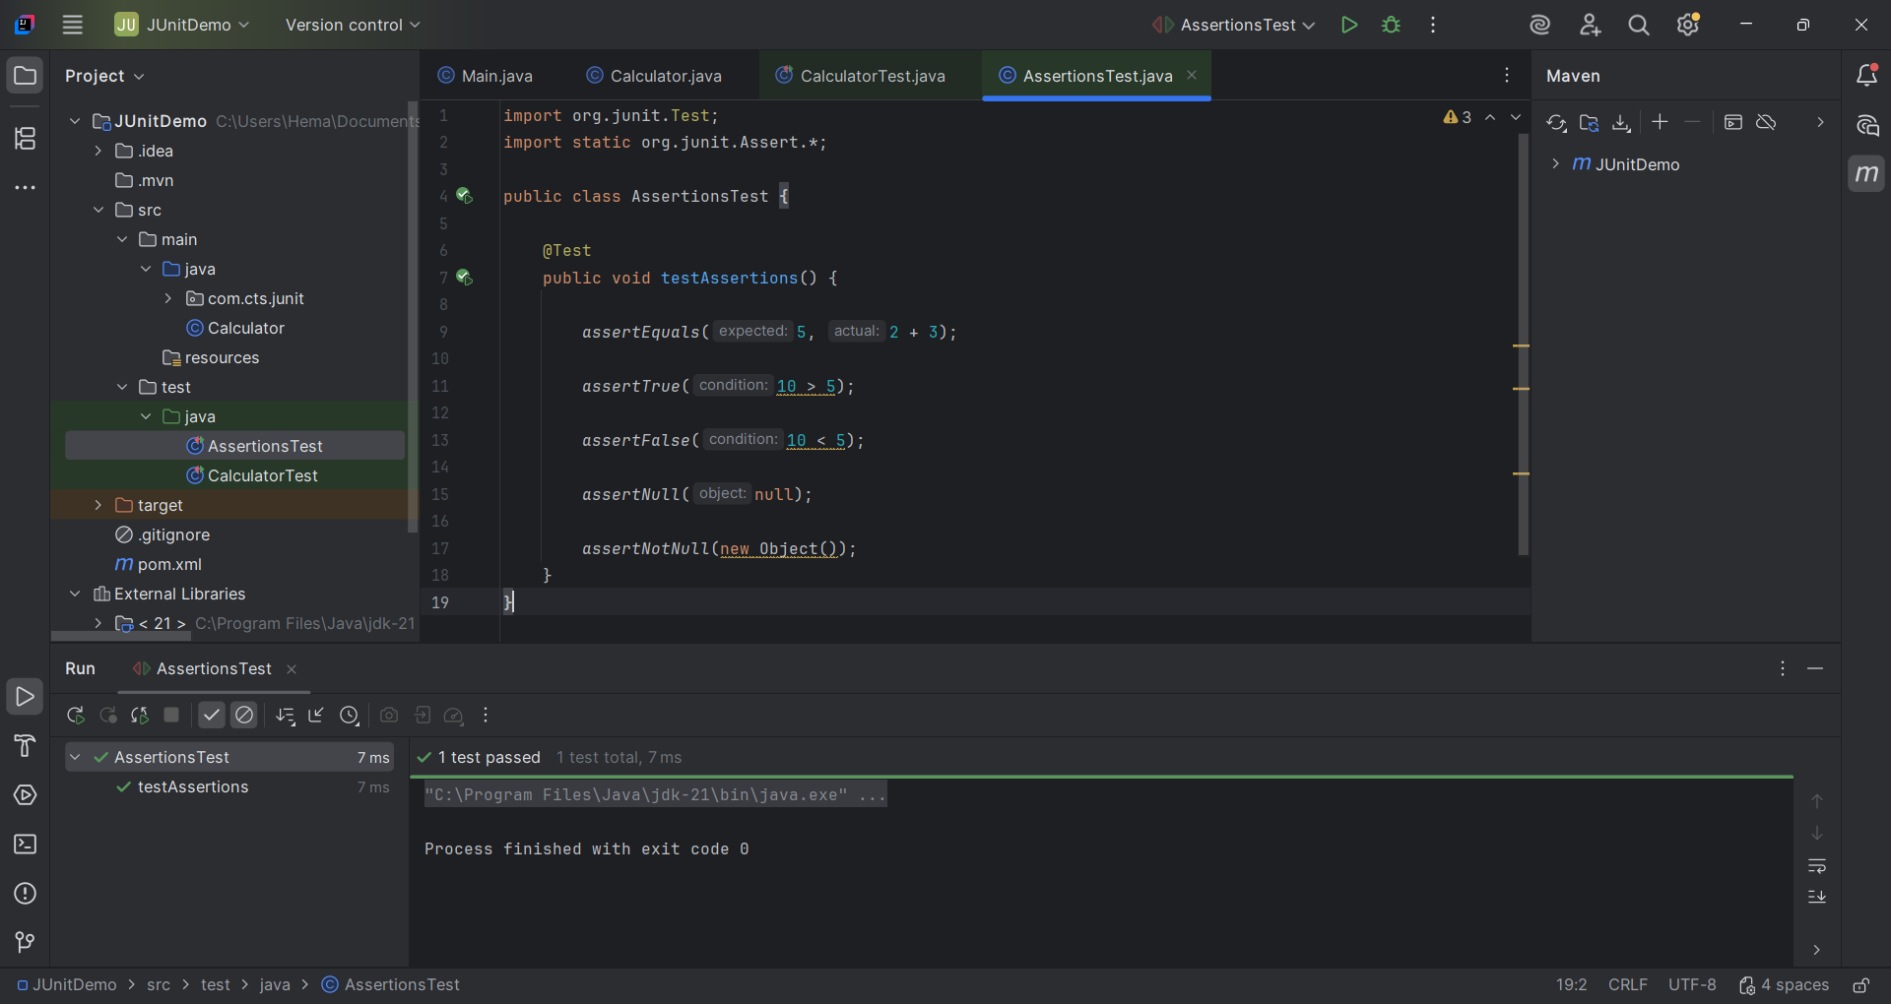
Exercise 4:
AAA pattern with setup and Tear down
